**MRSD Project Course Progress Review Presentation and Goals Guidelines**

1. Post to the Documents→Project management→Schedules portion of your website a round-robin list of the presenters for your team’s lab presentations in the Progress Reviews this semester. The dates for the Progress Reviews can be found in the course schedule on Canvas under Modules→Syllabus→Semester Schedule. There is no designated presenter for the Validation Demonstration and Validation Demonstration Encore.
2. Each presentation is worth 5 points. For weeks that you are the presenter, the 5 points are allocated based on your presentation and the success of the demonstration. For weeks that you are not the presenter, 5 points are allocated based on the success of the demonstration, overall team progress, your individual contribution, and your participation in the lab discussion. For presenters, the grade is weighted more heavily towards the presentation; for non-presenters, it is weighted more heavily towards the success of the demonstration. In all labs, integration of mechanism, sensing/electronics, and programming/control necessary to achieve functionality will be among the grading criteria.
3. Each presentation lasts 15 minutes, and the designated presenter presents for 6-8 minutes. The presenter should cover:

a. Progress

b. Challenges (including Issues Log and Risk Management updates)

c. Future work

The presenter should give at least a summary of all work accomplished by the team during the last period. The presenter should not “turn over” the presentation or parts of it to team members until he or she has at least summarized all work. Non-presenting teammates may then go into detail on particular topics. Please use slides and structure them so that each progress review goal (item 5 of this list) submitted to the instructors is clearly addressed. When discussing Challenges, include snapshots of the Issues Log and Risk Management tracker from your project website. All teammates should get involved in the discussion after the presentation.

1. The specific elements required for the initial lab (sensors & motor control) are highlighted in that assignment.
2. During the spring semester, you are required to email Progress Review goals to the instructor team. These should be ***concise***, bulletized goals that align with your project work breakdown and schedule. Here is a good example:
   * First test on grass (no paint)
   * Kalman filter preliminary results
   * Wireless E-stop integration
   * App/GUI performance analysis: more consistent data transfer, add visualization features
3. Attendance at Progress Reviews is required. One excused absence per semester is permitted. Valid excuses include a family emergency or illness. Students should inform the instructors ***before*** an absence in order to be excused. Unexcused absences result in a zero for the lab.

**MRSD Project Course Individual Lab Report (ILR) Guidelines**

**Turn-in & Grading**

1. An ILR must be submitted by each team member whenever there is a lab or Progress Review (except for the end-of-semester Validation Demonstration and Encore, which are worth 20 points each with no ILR due).
2. The ILR is worth 5 out of the 10 points for a given task.
3. You will receive a 0.5-point deduction for: 1) wrong format (other than PDF); 2) wrong filename (anything other than TeamX_andrewid_ILRXX.pdf).
4. The ILR is due via Canvas submission on the day after the associated lab/Progress Review at 11:59 p.m. (Canvas time). There is a 1-point deduction for late (by 11:59 p.m. of the next day) postings, and zero credit after that.

**Format**

1. Title page. Provide the following information ***on a single, separate title page*** at the beginning of the report:
   1. Information

Name

Team letter and name

Teammates

ILR number

Submission date

* 1. Example

N. G. Near

Team W: The Gearheads

Teammates: Thomas Edison, James Watt, Nikola Tesla, Dean Kamen

ILR01

Feb. 8, 2012

1. 850 to 1275 words of 12-point text (Arial, Calibri, Cambria, Helvetica, etc.: standard fonts, sans serif preferred) 1.15 spacing, 1” margins. This should correspond to 2-3 pages of text, not including figure(s).
2. Use a separate heading for four of the five required elements described below (Individual Progress, Challenges, Teamwork, and Plans). The figure(s) should be placed in the text where it makes most sense.
3. PDF format

**Content**

1. General
   1. Text
      1. Spend text on explaining and clarifying work and adding depth
      2. Don’t add “filler” material
      3. Proofread, including a spell and grammar check; don’t use slang
      4. Section headings help the reader
   2. Gripes (e.g., about teammates, the course in general, etc.) should come in person to us and should not be included in the ILR
   3. Do not include raw code in your ILR unless you are explicitly asked to, as is the case for the Sensors and Motor Control Lab. If you want to depict software, see 2.d.ii below.
2. The five required elements
   1. Individual progress
      1. What did you achieve since the last ILR/presentation? The description should give relevant and specific technical details, not just a brief mention of what you did. You could, for example, use this part of your ILR to document how to operate a portion of your project. This is especially valuable if your entire team is not aware of how to do the task you are describing.
   2. Challenges
      1. What difficulties or interesting problems did *you* face since the last ILR/presentation?
      2. Talk about expected challenges in the *future* under Plans below, not in this section.
      3. A challenge should be accompanied by some level of discussion, for example, an attempt to analyze the source of a problem, or suggested ways for addressing it. It isn’t sufficient to say simply, “we had a problem with A” and nothing more.
   3. Teamwork
      1. Describe complementary and joint work by teammates, mentioning each of them by name. Focus as much as possible on interactions among teammates.
      2. The goal of this element is to demonstrate your awareness of how your individual work relates to that of your teammates and to the system goals.
   4. Figure(s)
      1. Various figure types may be used (hand-drawn, CAD, photo (including from a cellphone), table, plot, flowchart, block diagram, schematic, circuit diagram, etc.).
      2. Do not include a software listing as a figure. If you want to use software as a figure, include a flowchart, pseudocode, or some other abstract representation of the ideas and processes underlying your software.
      3. An ILR may have an unlimited number of figures, but at least one must be unique. A figure is unique if no one else on the team has included it in his ILR. Students also may not recycle their own figures from earlier ILRs.
      4. Non-original figures and non-unique figures should be properly attributed. The former should have some kind of citation, URL, or other reference, and the latter should cite the teammate responsible for the figure.
      5. Each figure should have a number, a caption, and possibly labels.
         1. The text of the ILR should refer to each figure (by number) in a way which aids the reader’s overall understanding. Figures should not be inserted without being referred to in the text.
         2. The “caption” is the text immediately after the figure number under the figure. A “label” is a text box with an arrow that names and points to a specific element in the figure.
         3. Individual components in figures should be annotated using labels with pointers or arrows, especially for otherwise complex or confusing figures. Examples are a figure with a) many elements in it whose identity is not obvious without assistance; b) background clutter that requires “calling out” of the foreground elements of interest.
         4. Two good examples of numbered, captioned, and labeled figures are shown below (Figures 1 & 2).
   5. Plans
      1. This should include and focus on work the individual, not just the team in general, intends to do from now until the next lab demo.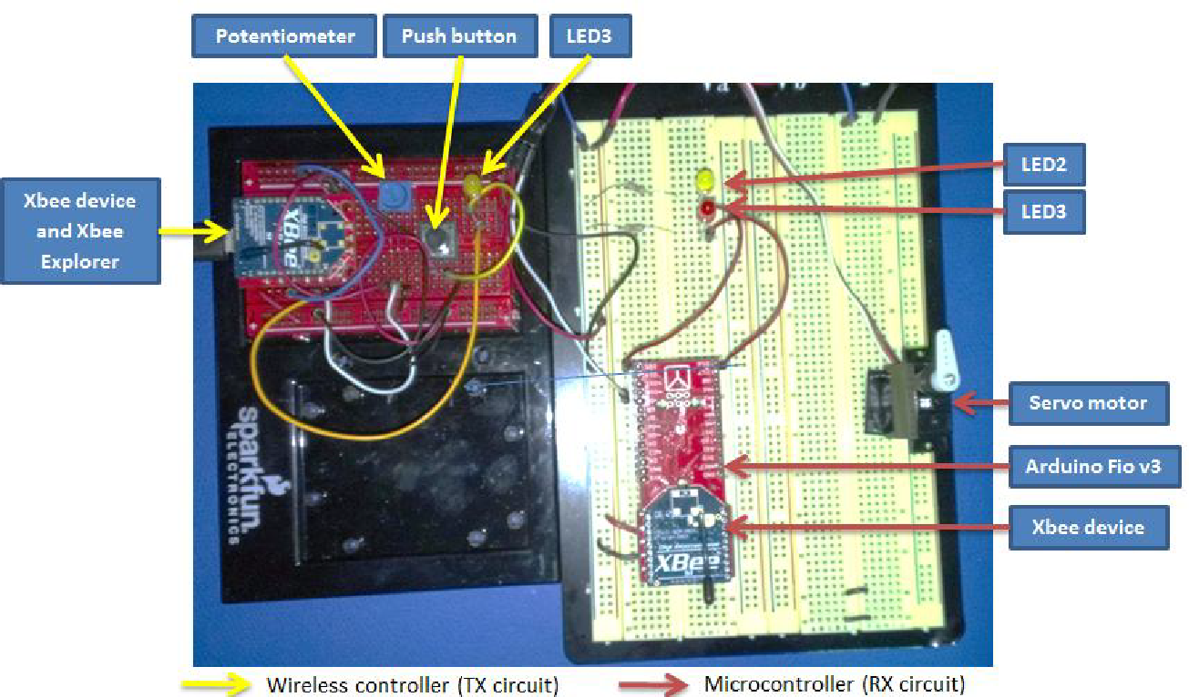

**Figure 1. Zigbee communication demonstration setup**

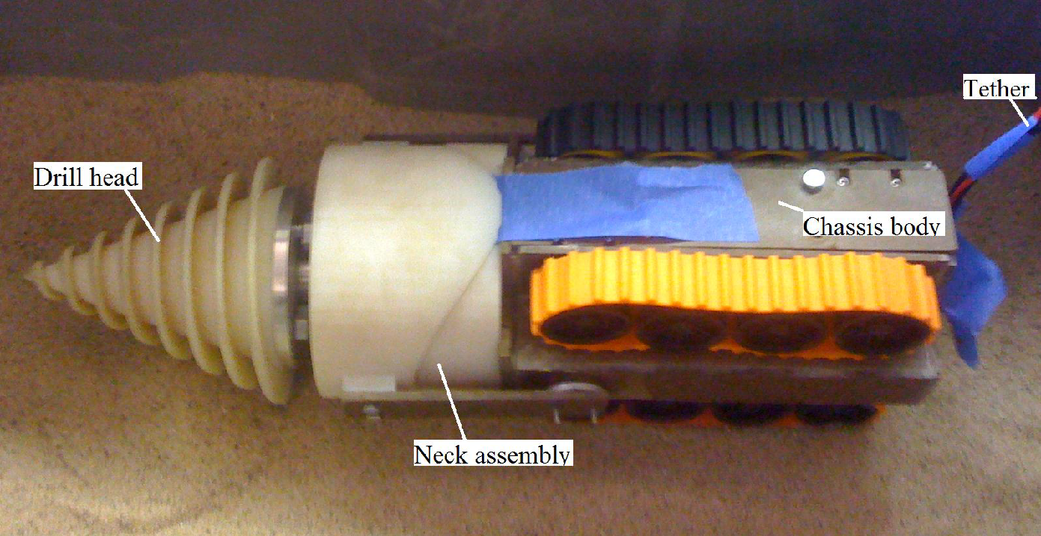

**Figure 2. Robot chassis (digging robot critical subsystem)**

**MRSD Project Course Team Meeting Guidelines**

1. The purpose of the team meetings is to discuss individually with each team recent progress, challenges, next steps, and the most current plans for the contents of the next two lab Progress Reviews.
2. The team meetings are not graded, and no formal presentation is required or prescribed. The team meetings are an opportunity for dialogue with the instructors and for bringing into focus project plans and potential problems. The suggested format/contents for a team meeting are listed below with the most important elements in ***bold italics***.
3. Please show up as a team a few minutes before your scheduled meeting time and wait outside the door.

**Spring Semester Team Meeting Contents**

1. What have you done since the last PR?  
    a. Each team member will individually:  
        i. Give a ***brief*** summary of recent activities  
***ii. Describe any problems faced so that we can discuss potential solutions from all sources***    b. After that, a brief wrap-up by a team spokesman is good, though not required  
2. What will you do before the next PR?  
    a. Each team member will individually give a brief summary of planned activities; these should line up with the team's requirements  
    b. After that, a brief wrap-up by a team spokesman is required to highlight coherent team effort  
***c. End result: agreed-upon set of goals for the next PR***3. Systems Engineering review  
    a. Review (any changes in) System Requirements  
***b. Review Spring Validation Demonstration, ensure it maps to the requirements***    c. Report on sponsor interactions  
***d. Risk Analysis: Identify your biggest technical and non-technical risks and their mitigation***

**Fall Semester Team Meeting Contents**

1. Describe any problems faced so that we can discuss potential solutions from all sources
2. Risk Analysis: Identify your biggest technical and non-technical risks and their mitigation
3. Agreed-upon set of goals for the next two PRs
4. Review Fall Validation Demonstration, ensure it is supported by the PR goals